**TRACK 1 ASSIGNMENT**

**Wine quality prediction model**

* **By Aditya verma**
* **DATE 2/6/2025**

DATASET USED

Wine quality.csv

<https://drive.google.com/file/d/1C9wDZcosuFLvc54gtKia_yQiAdsaK-SA/view?usp=classroom_web&authuser=0>

Aim

To make the model to test the quality of wine

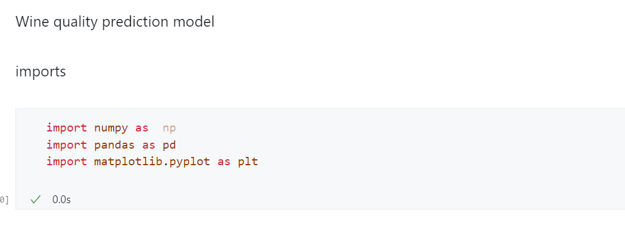

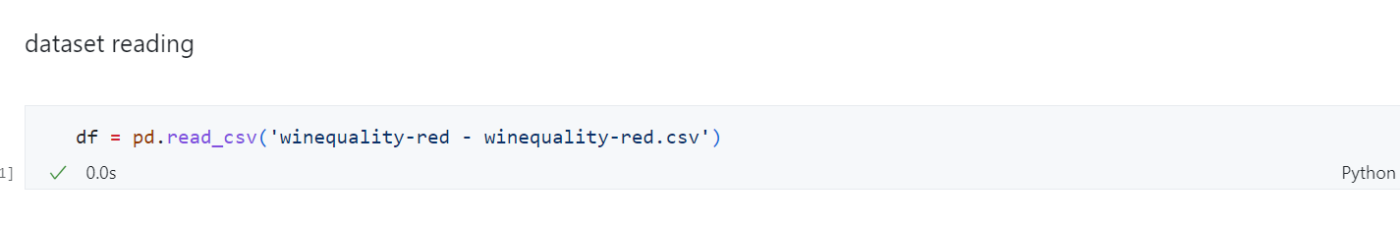

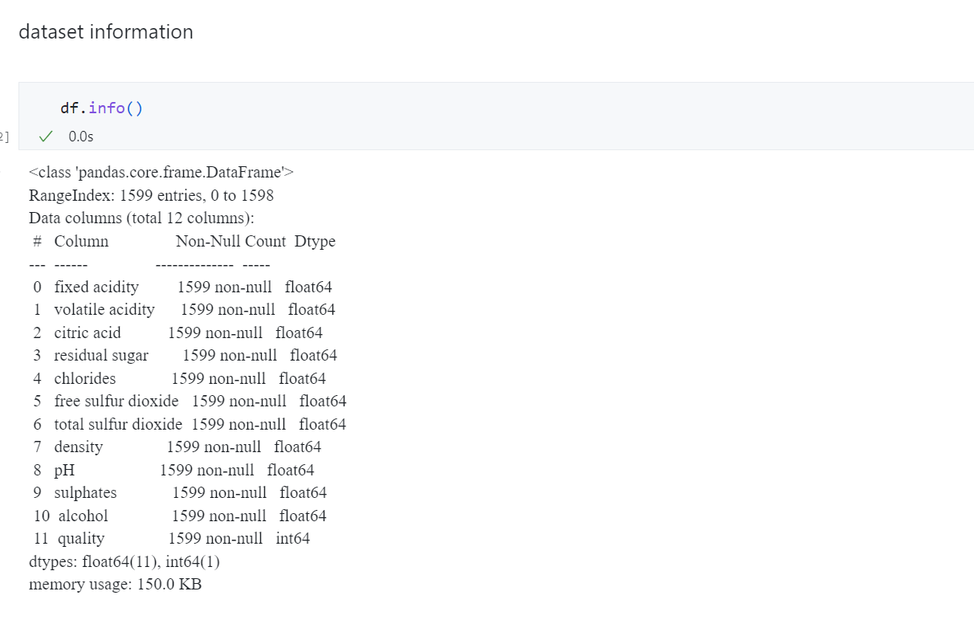

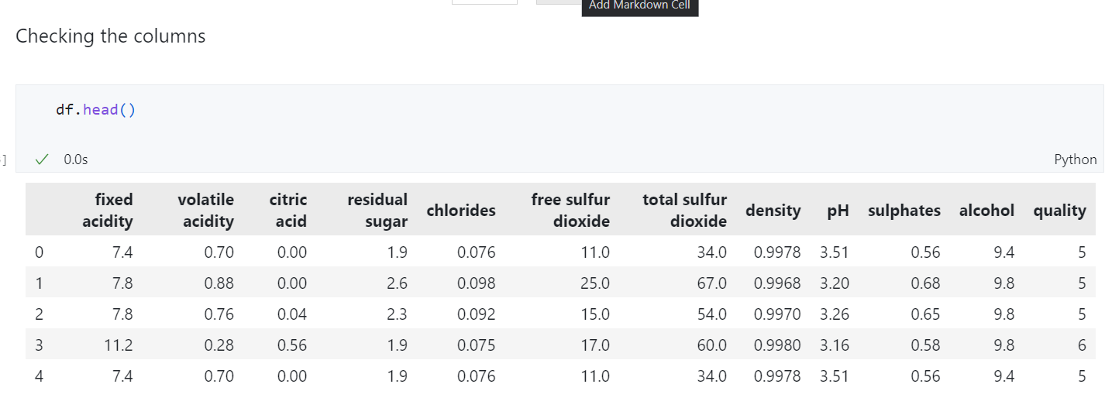

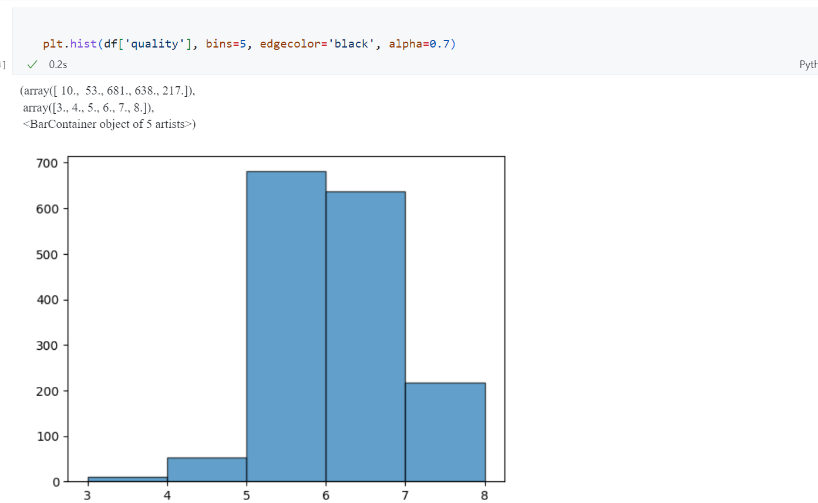

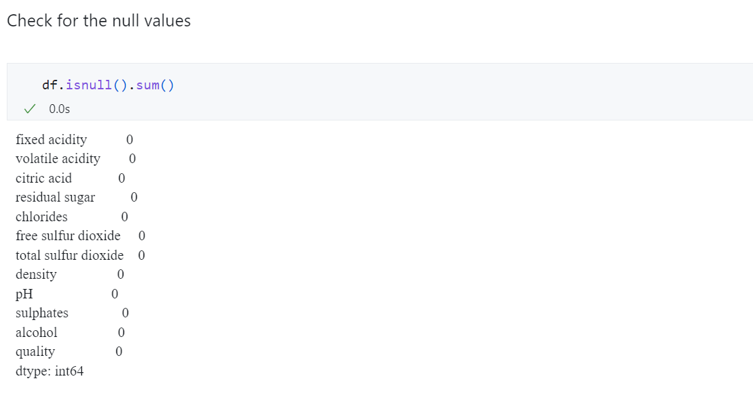

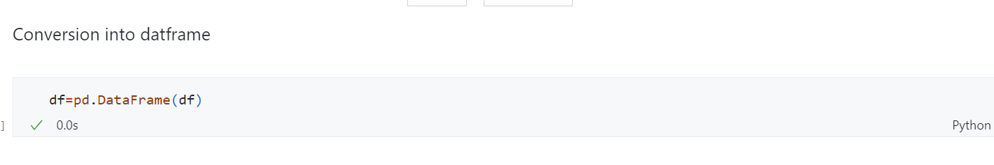

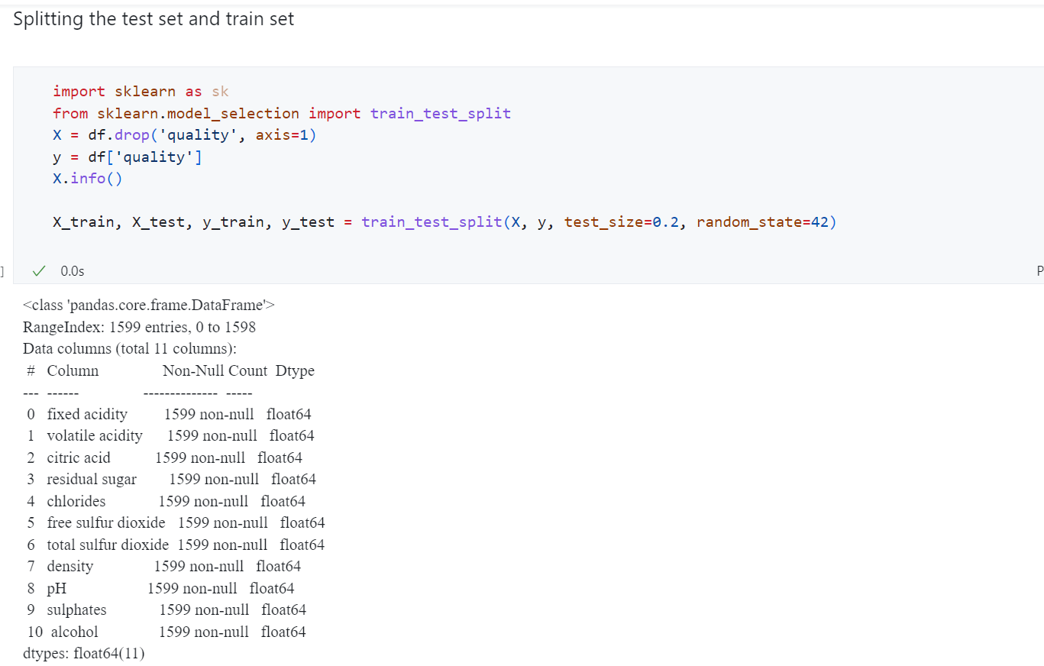

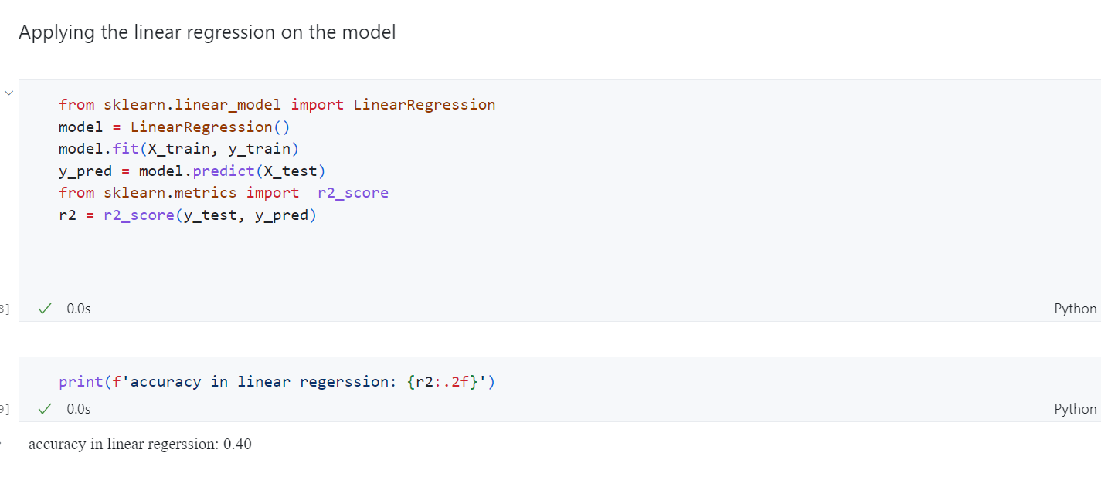

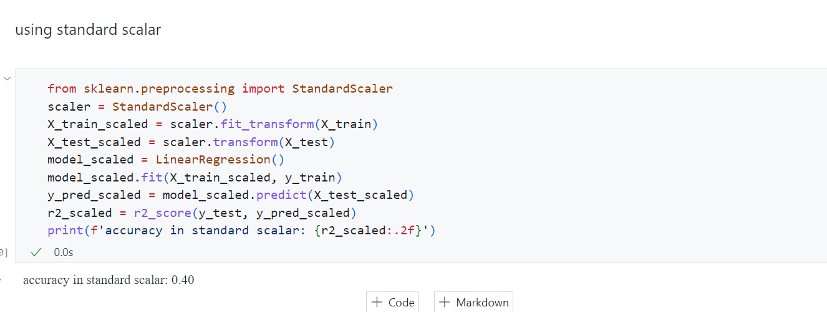

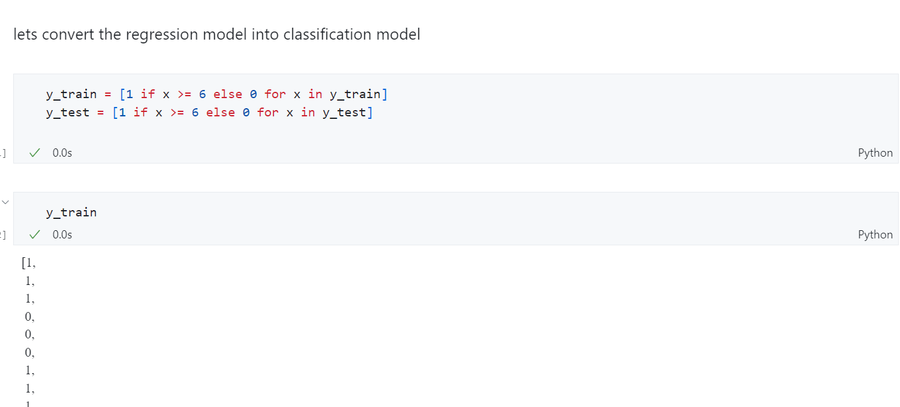

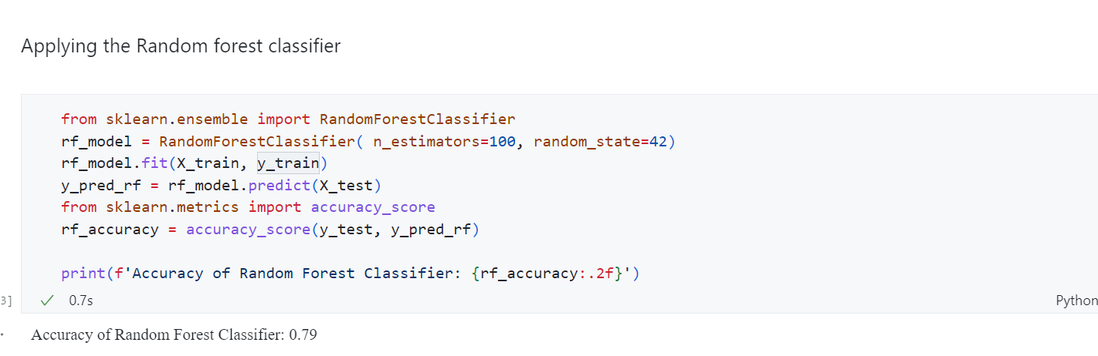

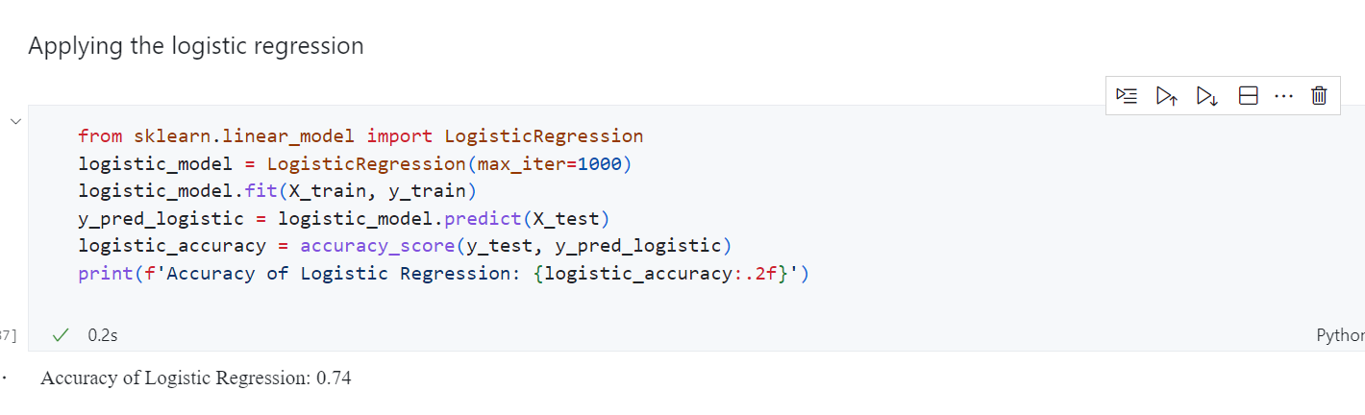

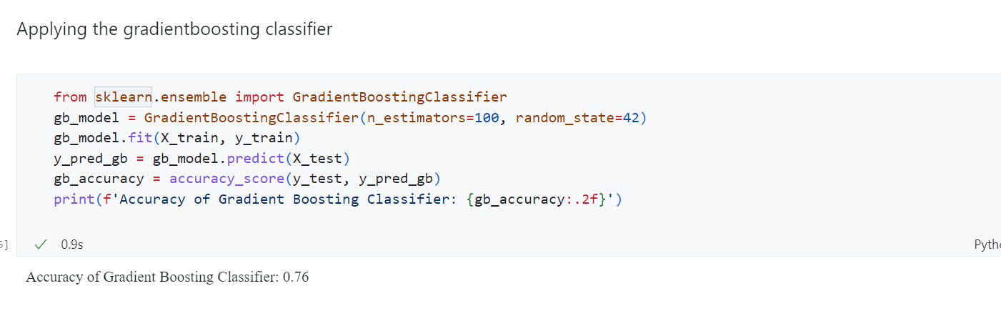

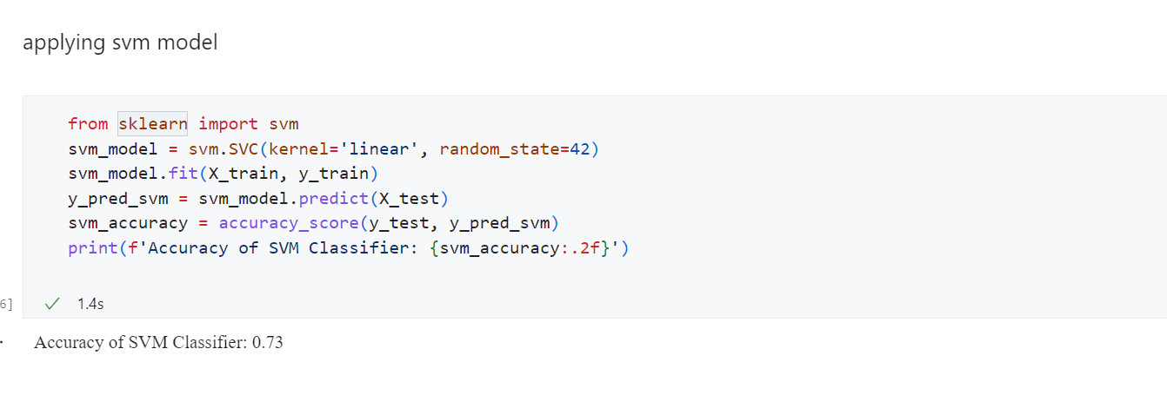

**CONCLUSION**

The accuracy in the various algorithms are

1. Regression :-

Linear regression - 0.40

Standard scalar - 0.40

1. Classification :-

Random forest classifier - 0.79

Logistic regression - 0.74

Gradient boosting classifier - 0.76

Svm model - 0.73

**Link of the notebook :**

[**task2.ipynb**](https://colab.research.google.com/drive/1r81tYMih-w8hNJAsCCaZNLFB8qoItKqK?usp=sharing)

**Or**

<https://colab.research.google.com/drive/1r81tYMih-w8hNJAsCCaZNLFB8qoItKqK?usp=sharing>